Latin America Conquests and Conquistadors Graphic Organizer

Aztecs
Live in central Mexico from 1200-1500s. They were fierce warriors who took over many neighboring peoples and offered human sacrifices to please their gods. They built their capital in the middle of Lake Texcoco and named it Tenochtitlan. Its location protected them from enemies. At its peak it included more than 5 million people. They grew crops on floating gardens on the surface of Lake Texcoco. They also built causeways (bridges) to get in and out of Tenochtitlan. There were metalworkers and pottery makers. They had a calendar.

Montezuma was their last leader
Hernan Cortes
In 1519 Hernan Cortes entered Mexico with an army of 600 soldiers When Montezuma first saw Cortes, he thought he was a god and welcomed him.
The Aztecs were afraid of the Spanish horses, guns and cannons. The Spanish also brought diseases such as small pox with them.
Cortes kidnapped Montezuma and Montezuma was killed

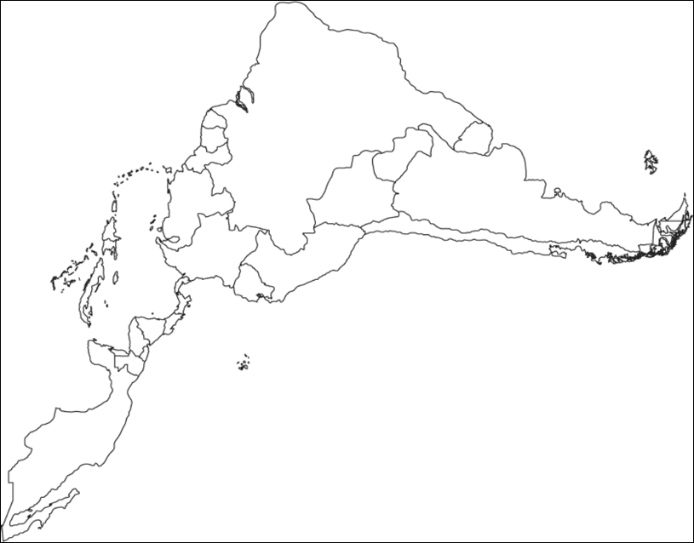

Inca
By 1400 The Inca Empire had about 12 million people along the coast of South America along the Andes Mountains. Its capital Cuzco.
They farmed on mountains thru terrace farming. They had irrigation canals to water their crops. They built a system of roads still used today. Since they did not have a written language they had runners carried messages in a relay system. Messages could travel 150 miles in a day.
They also kept records on quipu which were knotted strings.

Atahualpa was their last leader
Francisco Pizarro
In 1532 Pizarro came to South America with 180 men. After arranging a meeting with Atahualpa, Pizarro kidnapped him. Atahualpa attempted to buy his freedom by offering rooms filled with gold and silver. The Spanish happily took the treasure but killed him anyway. Pizarro captured the capital city of Cuzco and then moved into other Inca lands.
Many Inca also died of European diseases

.

